



Final Packet

Segment:
College Athletics Department Administrators

Team:
Catherine Armstrong, Sydney Brown, Susannah Hotovec, Sarah Matlick & Thalia Stoffers
Table of Contents

Situational Analysis…………………………………………………...3
Executive Summary……………………………………..............3
Target Audience…………………………………………............3
SWOT Analysis…………………………………………............4
Research………………………………………………………............5
Audience Profiles……………………………………………….5
Audience Personas………………………………………...........6
Communication Audit…………………………………………..8
Case Studies…………………………………………………....11
Mini-Plan……………………………………………………............15
Goals & Objectives………………………………………........15
Strategy………………………………………………………..15
Tactics…………………………………………………………15
Timelines…………………………………………………………….17
Evaluation…………………………………………………………...18
Budget……………………………………………………………….19
Deliverables…………………………………………………………20
Blogs…………………………………………………………..21
Social Posts…………………………………………………....27
Website Recommendations…………………………………....36
Key Messaging Matrix………………………………………..38
Asset Tracker………………………………………………….38
Next Steps & Future Recommendations…………………………….39

Situational Analysis

Executive Summary

Organization Background

Monarc is a Dallas-based innovative football technology company started by Igor Karlicic and Bhargav Maganti. Monarc’s Seeker technology is reimagining how college and professional football athletes train. The founders invented The Seeker, the world's first robotic AI quarterback, kicker, and punter, to satisfy the demand of players seeking high-volume repetitions for independent catching practice without requiring a team practice environment.
Currently, Monarc is limited to showing their technology to potential clientele and buyers through in-person demonstrations that infrequently occur across the country. Monarc can show the product virtually, however, it has proven to be more effective when demonstrations occur in front of a buyer. The Seeker has attracted investment from NFL players such as Hunter Henry, George Kittle, and Mohamed Sanu. The University of Virginia was the first football team to purchase The Seeker. Monarc now has 25 college football clients utilizing The Seeker to improve their training regime and athletic performance.

Project Background

This project works to address how we can increase awareness and ultimately drive sales from one of Monarc’s main audience segments – college athletics department administrators. We chose this audience segment because of their oversight of college program budgets, ability to distinguish their program from others from behind the scenes, and their consistent focus on advancing their programs.
One of the biggest hurdles that Monarc faces when connecting with college administrators is making connections. We have determined three ways of securing stronger relationships between Monarc and administrators by focusing on the audience’s goals of striving for team betterment and effectively utilizing team budgets.

Target Audience

Our target audience is college athletics department administrators. Monarc is looking to build its clientele through this demographic due to its influence on the decision-making in programs. Monarc is not limiting whom it wants to make connections with, as it is interested in reaching any team within the Power 5. However, Monarc considers Pac-12 teams to be the most influential on lower-level teams and what lower-level teams will use and buy for training their athletes.

SWOT Analysis

STRENGTHS  - Monarc has 25 partnerships with major college programs, like Arizona State University, showing reputability and industry impact.  - Monarc owns and posts on LinkedIn and Twitter – two of the most widely used professional outreach platforms in the demographic.  - Appeals to college athletic department admin as the technology works towards bettering team experience and playing results.  - Monarc has no direct competitors. | WEAKNESSES  - Lacks consistent posting on LinkedIn with a moderate following. Can combat this through high-quality written and visual content, paid promotional campaigns, and hashtag strategizing.  - There is no consistent messaging directed towards the target, on any owned social channel. The website lacks to address the concerns of administrators– such as the goal of enhancing college programs. Can this combat though: infographics highlighting the Seeker’s ability to future-proof teams and show a return on investment and stronger written content.
OPPORTUNITIES  - Reach and remain relevant to admin in personal yet professional ways, such as a blog feature. Blogs are proven to strengthen long-term partnership bonds and customer retention.  - College administrators utilize social media forums like Twitter to engage with other colleges and prospective students. Can utilize Monarc’s Twitter platform to resonate and connect with audience. | THREATS  - Other companies target admin for football practicing technology and or tools. Can combat this through: marketing that establishes the product is one-of-a-kind and first of this kind of technology.  - Despite the large number of existing college sports administrators, they have tailored email and communication channels making it vital to use strategic messaging.  - Admin are looking for a potential return on investment for services with an expense like The Seeker.
Research

Audience Profiles

Demographics

- The college athletic department administrators’ demographic is made up of 78.2% males and 21.8% females.
- The average age for white males (and females) in this segment is 48 years old.
- 75% of athletic directors are 40+ years old. ⁶
- 69% of all athletic directors have a bachelor’s degree. ⁶
- 65.7% of this demographic is white, while 13.8% are Hispanic/Latino, and 11.5% are African American. ⁵

Psychographics

- The college athletic department administrators’ demographic is made up of mostly Gen X (ages 43-58) individuals. The attributes of Gen X often consistent of being independent, resourceful, educated, and tech-savvy. Gen X individuals prioritize family, having a work-life balance, and prioritize responsibility, quality lifestyle, and community.
- (Comms Objective) 78% of college athletic department administrators are active on social media with 48% being Twitter users and 40% using LinkedIn – with 50% of adults who have a bachelor’s degree being LinkedIn users.
- (Other Uses) 81% of this audience uses Facebook and 47% use Instagram. ⁸
- Sport-related Traits: 40% of white males prefer watching the NBA, whereas MLB has the highest male-dominated audience overall at 70%.

Audience Personas
Mid-Career Mike
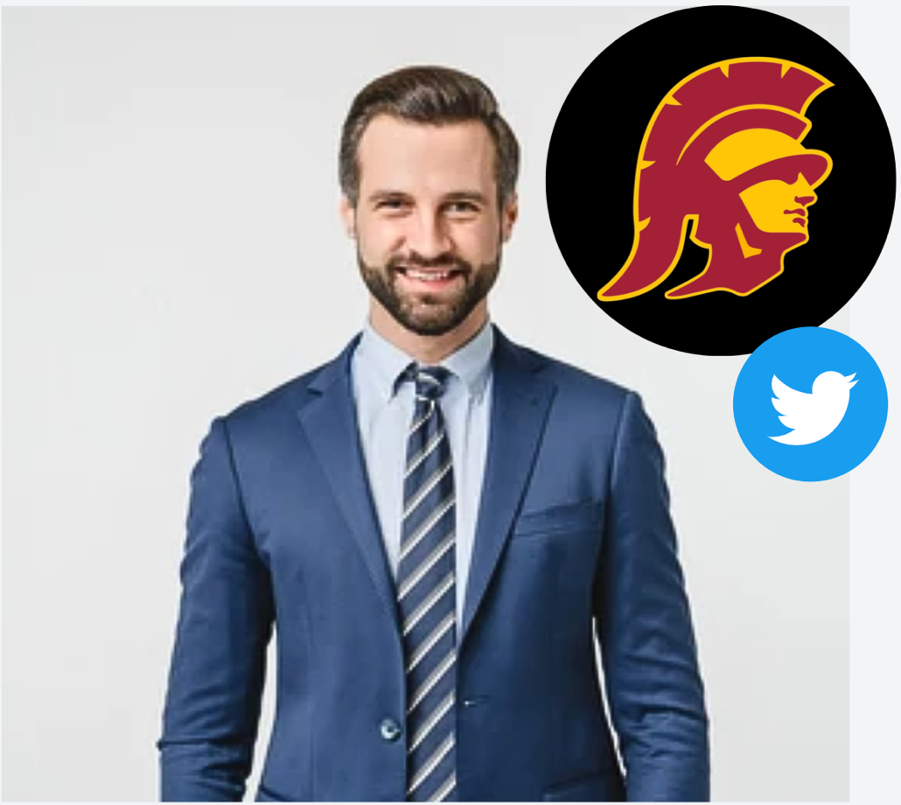

- 43-year-old white man
- Position: USC’s Chief Financial Officer for Football Operations
- Has been a part of the PAC-12 since 2012 – previously worked at UCLA as an Athletics Revenue Officer.
- Serves as a sports administrator who manages USC’s football budget and oversees equipment and technology purchases. Acts as a liaison for partnerships. Always looking for a potential return on investment before any negotiation.
  - Passionate about finance and his career
- Personal Life: Brian enjoys raising his 2 daughters in Los Angeles with his wife Elizabeth. During his free time, Brian watches the Dodgers and visits his social media apps 3-4 times a day.
- Media use: Has LinkedIn (325 connections) and utilizes it professionally to connect with other football program directors and coaches on the west coast – nearest him. He favors Twitter (549 followers) for both social and professional use as he shares behind-the-scenes photos and tweets about how USC’s football team is advancing each week and makes connections for the team.

WHY: Younger side of the demographic, has budget oversight, is an example of our Twitter audience.
Seasoned Vet. Victor
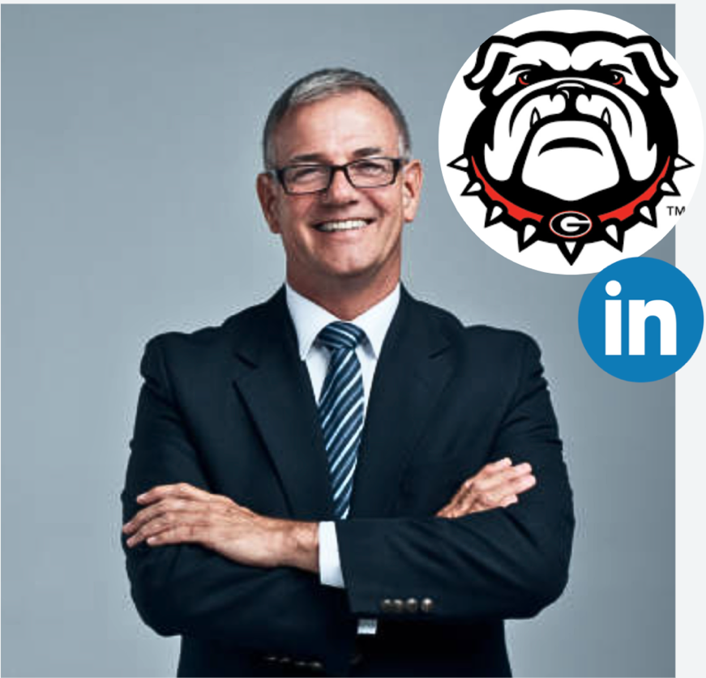

- 58-year-old white man
- Position: Senior Director for Football Operations at the University of Georgia
- Has been at UGA since 2018. Before UGA, he was the Associate Director of Football Administration at UT for 15 years.
- Victor supervises the football team’s day-to-day operations.
- Victor develops the program through acquiring practice and conditioning tools, marketing opportunities, and has recruiting and hiring oversight.
  - His aged passion for college football makes him dedicated to the best operations for player and fan experience.
- Goals: Victor considers bettering each player’s individual progress as his #1 priority. He is currently seeking ways to improve Georgia’s football team by implementing new high-quality practice tools and thus leave a long-lasting legacy of team betterment.
- Media used: Uses Twitter (122 followers) to engage with content about his favorite sports teams like the Atlanta Hawks. He frequently uses Instagram (65 followers) but keeps it private for family and friends. Has used LinkedIn (613 connections) in the past 6 months to post about specific partnerships and updates of the UGA football team – letting other industry professionals his impact and celebrating new advancements.

WHY: Older side of the demographic, cares about the impact of day-to-day operations, example of our LinkedIn audience.
Communication and Competitive Audit

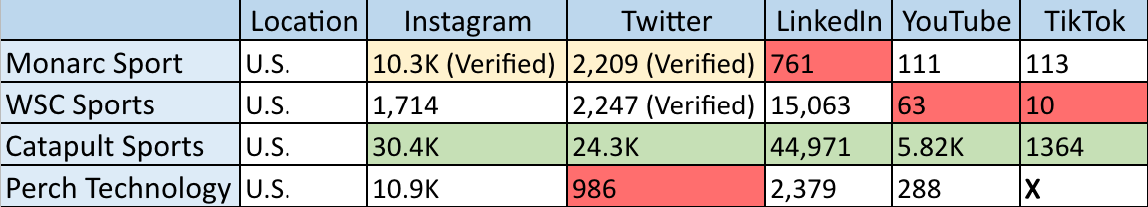

Based on our communication and competitive audit, Monarc’s social media footprint falls in the middle of the pack with potential competitors. In comparison to other companies Monarc is one of the only brands to have both verifications on Instagram and Twitter. However, numbers wise, on both platforms they fall in the middle of the pack. On LinkedIn, Monarc has the most room for growth. Lastly, on video-based content platforms, such as YouTube and TikTok, Monarc’s numbers, though not the lowest, still shows room for improvement. When zeroing in on the platforms that the target audience of college administrators use, there is the most room for development on Monarc’s LinkedIn and Twitter. Examples include positing short-form video content on Twitter, such as Catapult Sports does on LinkedIn, or the utilization of hashtags WSC Sports does on Twitter.

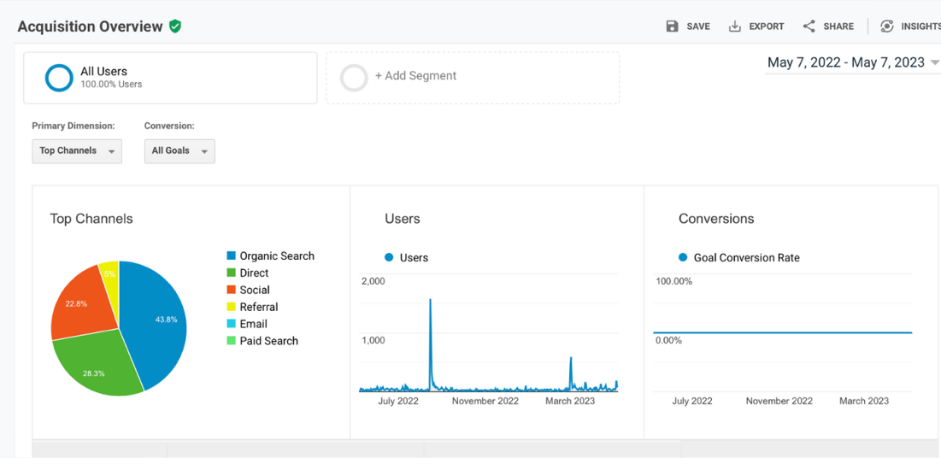
Google Analytics Report

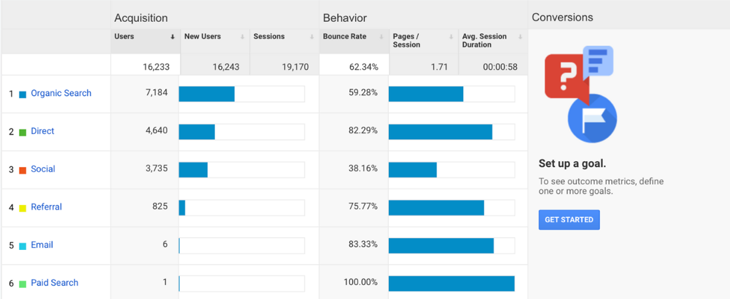

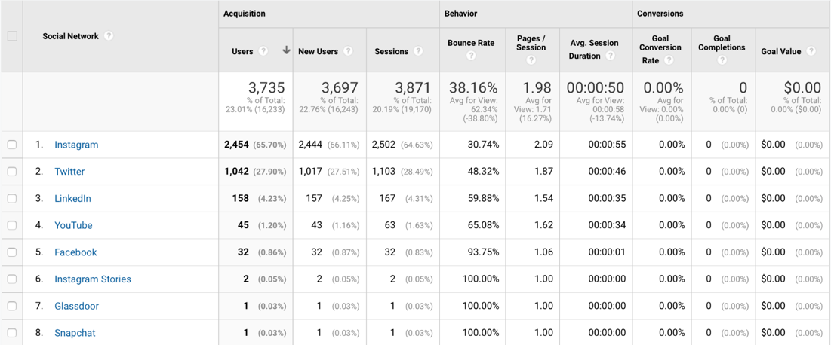

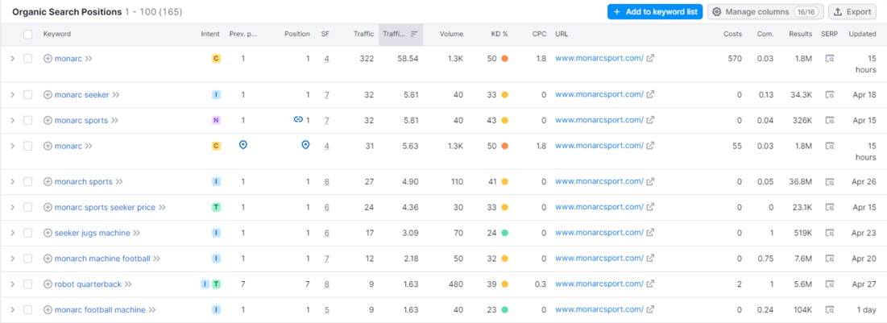
SEM Rush
Report

When looking at Monarc’s Google Analytics breakdown, we can see that Monarc website users come from organic searches, followed by direct searches and social media. To begin with, for social media, Monarc will want to increase the number of website views coming from Twitter and LinkedIn when considering the target audience of college football administrators. Based off our research, we know that our target audience use Twitter and LinkedIn for professional use and frequent those social media platforms in their daily lives and to build program relationships. Additionally, when considering organic and direct searches, Monarc needs to prioritize search engine optimization with keywords, such as the ones found on SEM Rush, which can be used to continue to grow numbers in both areas.

Key Insights

- Room for improvement in followers on Twitter and LinkedIn numbers, both followers and users, in comparison to other sports technology companies when it comes to targeting college football administrators.
- Use SEO Keyword searches to Monarc’s advantage for website to continue to increase the number of website users.
- Video content does well on LinkedIn to enhance posts, such as for Catapult Sports.
- Hashtag utilization is a great way to reach target audience, such as what’s done by WSC Sport.

Case Studies

#1. WSC Sports website Connects with Sports Administrators

- WSC’s AI platform enables sports media owners to generate personalized and customized sports videos automatically and in real time. However, they needed to communicate with sports administrators effectively to prove why their technology is worth implementing into their programs.
- WSC Sports website effectively shows how they work to help with maximizing the use of a sports program’s video content to increase their reach and provide new monetization opportunities. On their homepage, they show video example clips their technology has created, many sports industries that they work with, an explanation of their product, and links to press articles about their company.
- WSC work with over 300 sports organizations. An example would be how the University of Pittsburgh has now gained hundreds of thousands of views on social media and millions of video impressions with its technology.

Image Examples
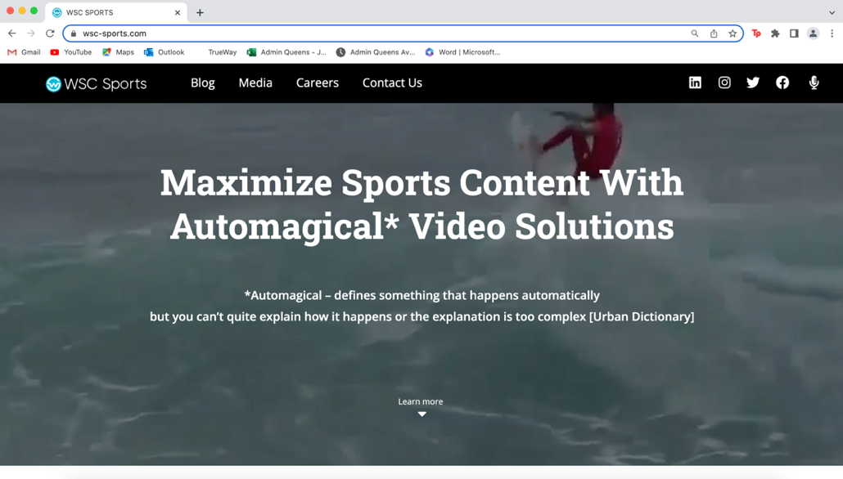

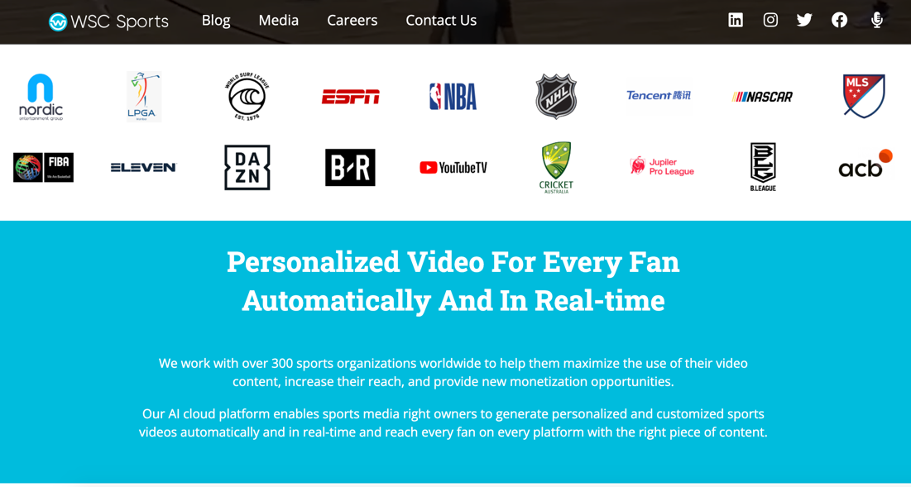

#2. How Catapult Sports’ Website Targets an Administrative Audience

- Catapult Sports creates wearable sports monitoring technology to track how athletes move throughout their workouts. They needed to create a website to target selling their product to college administrative teams to show how their technology works and why it’s worth investing in.
- Created a well-organized homepage and navigation that effectively shows who they are, what their technology is, program user stories, and how to contact them.
- Catapult Sports created a user-friendly website by optimizing their owned digital space to connect with team administrators. As a result, they have worked with many college football teams, including Baylor and Sacramento State, as well as other sports programs around the world.

Image Examples

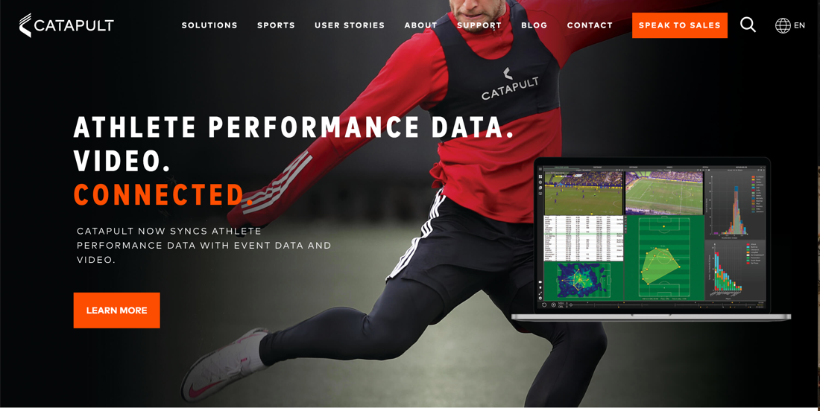

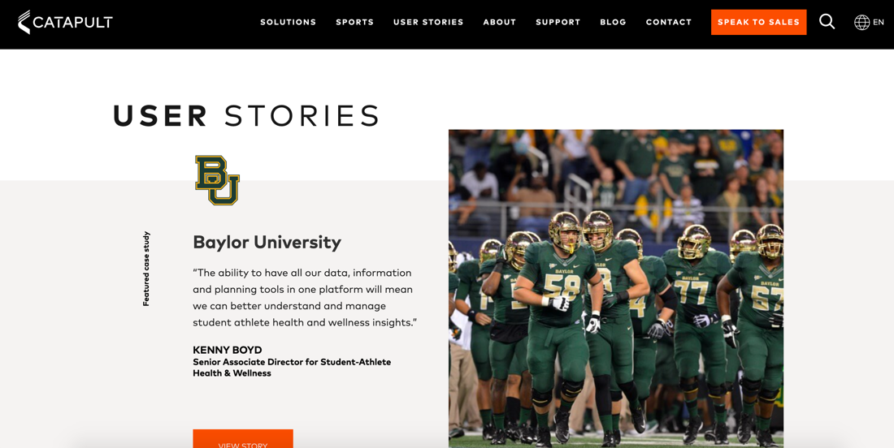

#3. Ohio University Partners with Teamworks Elite

- Teamworks announced its partnership with Ohio University in August of 2022
- OU. One OU athletic director described the collaboration as exciting as it will “enhance the student-athlete experience.”
- OU became a Teamworks Elite partner which offers them a package with resources like “Teamworks Academic” for athlete academic needs and “INFLCR Core” for brand-building content creation.
- Teamworks CEO, Zach Maurdies, said he was “thrilled” about the partnership as Teamworks Elite will allow OU students to thrive in athletics and academics.
- Teamworks announced this partnership on their blog forum which updates users, like college admin, on recent industry developments.
- Teamworks utilized its blog feature to announce this with strengths in both user engagement and relationships among partners.
- Utilized digital imagery to cast a visual partnership between the OU Bobcats and Teamworks.

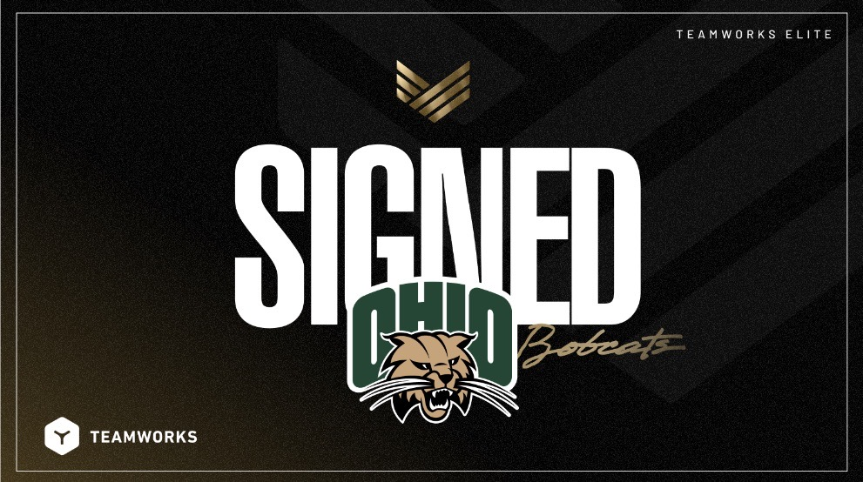
Image Examples

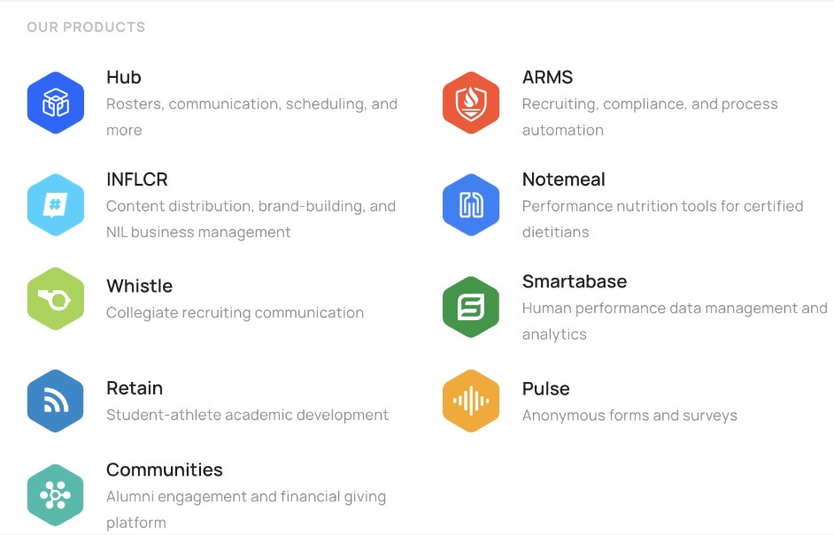

Key Insights
- There is an ability to maximize monetization opportunities through professional and high-quality video and photo content.
- Strong websites have easy-to-navigate and eye-catching homepages.
- A blog feature on a website announces and highlights strong partnerships with clients.

Mini-Plan

Goals & Objectives

Business and Communication Goals

- We want to position Monarc as an exclusive football performance technology company with one-of-a-kind technology that will prove to college administrators 1) The Seeker’s ability to improve programs and program experience and 2) shows ROI.
- Given Monarc's professional social media use preferences, we aim to expand our outreach to college administrators and increase sales overall by targeting this demographic through Monarc's website, LinkedIn and Twitter – the amplification of blog posts from the website with be posted on LinkedIn and Twitter.

Objective

Our objective is for Monarc to be recognized by college administrators as a credible technology company in the football industry that helps teams improve how they train as measured by a 30% increase in content consumption by December 1, 2023.

Strategy 1:

To accomplish the objective, we recommend a social channels strategy that will leverage Monarc’ preexisting college administrative following, while attracting new college administrator clientele through enhancing Monarc website’s and social media accounts.

Tactics

#1. Blog

Sub-Tactics

  - Blog post explaining the rise of AI technology in sports, highlights the AI technology Monarc uses, and explains how Monarc is committed to improving its technology.
  - Blog post highlighting partnership between Marvin Harrison Jr., Ohio State and Monarc.
  - Announce that the Arizona State University football program partnered with Monarc on March 27, 2023.
  - Amplify the three blog posts on LinkedIn and Twitter. Use curated social posts, image assets and hashtag strategizing to boost the content to our target audience.

#2. Website
Sub-Tactics

  - Website communication audit encompassing Search Engine Optimization recommendations for Monarc's website.
  - Website competitive audit to compare Monarc's website to its competitors.
  - Website and social media posting chart to optimize engagement amongst the audience when blogs and social posts are uploaded.

#3. Social Posts

Sub-Tactics

  - Create a message matrix that provides content manager resources on optimizing key messages for the audience.
  - Twitter campaign for targeting administrative personnel.
  - LinkedIn campaign for targeting administrative personnel.
  - Create Social Editorial Calendar based on the best posting times and the needs of our audience profiles – for LinkedIn and Twitter.

Timeline

Timeline, After hand-off

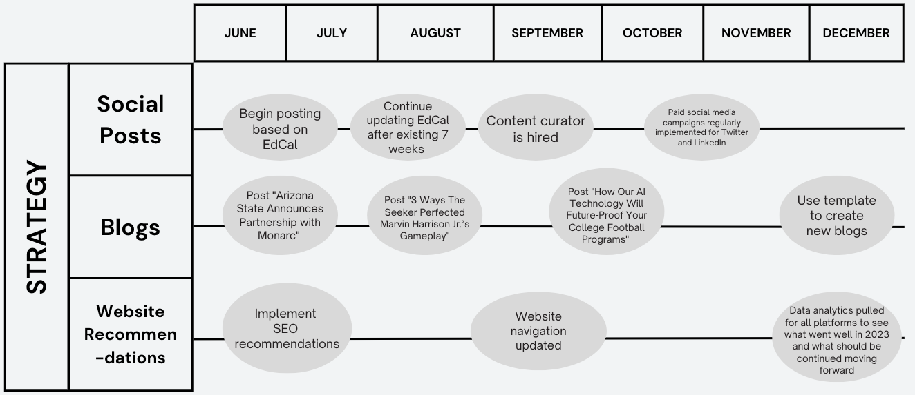

Evaluation

KPI | Detail Items | Benchmarks for Success
Blog | Views, shares, comments, reaction around university partnership and player spotlight, time spent on reading posts, engagement with “ways to connect” feature at bottom of blog | ^ 5% increase in client communication and outreach to Monarc  ^ ≥10 connections with admin made through blog
Website | Number of searches for Monarc, time spent on website, number of website shares, conversion ratio of traffic on website and purchases of the Seeker, SEO | ^ 10% increase in brand awareness through strong SEO presence
Social Posts | Followers, interactions on posts including comments and likes, how many features on Football Scoop, conversion ratio between social media, Football Scoop into real customers | ^ 5% follower increase on Twitter  ^ 20% follower increase on LinkedIn  ^ ≥10 features on Football Scoop  ^ ≥ 5 features on Teamworks

Blog: We will evaluate the effectiveness of the blog by measuring the growth of awareness from college administrators. This will be conducted by considering audience reactions in the comment section, measuring interactions such as likes and shares, and popularity in terms of if administrators shared or engaged in posts – such as partnership announcements. We will evaluate the blog and determine an at least 5% increase in administrative client communication, who said they read or found Monarc through a blog post, as effective. Because each blog post will have a “ways to connect” option, we will deem 10 college administrators reaching Monarc through that means as effective.

Website: We will then evaluate the effectiveness of revamping the Monarc website by determining a 10% increase in brand awareness, made through a strong SEO presence, as effective. Using search engine evaluation, we will determine content from tactics like blog and social media coming as first results from searches like “Monarc,” “football technology,” and “football practice tools” as effective.

Social posts: We will evaluate the success of social media campaigns through the increase of followers. We will deem an increase of 5% followers on Twitter, 20% follower increase on LinkedIn, ≥10 features on Football Scoop, and ≥ 5 features on Teamworks as a success.
Budget

Tactic | Sub-Tactic | Unit | Quantity | Budget
1 | Social Media Campaigns | 7-week Twitter campaign | 15 Twitter posts | Cost of “Twitter Promote mode” per month = 99  per week = $24.75  Total: $ 173.25
 |  | 7-week LinkedIn campaign | 15 LinkedIn posts | LinkedIn post per day = 25  Total: $ 375
2 | Blog | Hyper-boost of blogs through social posts | 3 LinkedIn posts  3 Twitter posts | $25 per LinkedIn post per day = $75  $3.55 per Tweet per day = $10.65  Total: $ 85.65
3 | Website Recommendations | SEO Rush Pro (Guru) | 1 months’ worth subscription | Total: $ 229.95
 |  | Pro Fivver website designer | 1 time | Total: $ 1,500
Estimated Total |  |  |  | $ 2,363.85

This budget will be flexible depending on the increase or decrease on decided timeframes to implement these specific tactics. One interchangeable variable is how long you choose to run your social media campaign, as these prices are set for a 7-week long campaign, based off our provided EdCal. SEM Rush Guru and Fivver are fixed costs but only account for a one-time subscription purchase. A second interchangeable variable will come if choosing to implement our future recommendations that are to follow on the subsequent pages. The addition of additional salaries and therefore staff – will need to be decided upon and could thus change the budget. Our future recommendations outline the additional cost of such implementations. While a paid LinkedIn promotion could start as low as $10/day, we have utilized a $25/day recommendation to start the campaign at a higher success rate.

Deliverables

#1. Blogs

Blog 1 –"How The Seeker's AI Technology Will Future-Proof Your College Football Program"

- Summary & Purpose:
  - Blog post explaining the rise of AI technology in sports, highlights the AI technology Monarc uses, and explains how Monarc is committed to improving its technology. Emphasizes how the Seeker works to future-proof the success of teams. The header image shown is an example of what a header of this blog could look like on the website.
- Key Quotes:
  - “The Seeker combines AI, the Internet of Things, programmability, and more to enable football players to practice by themselves. Why Windows and Azure? They maintain greater choice and flexibility in evolving the product.” – Microsoft

  - “[AI can monitor athletes’ progress, provide valuable feedback on areas that need improvement, allow coaches to better understand their opponents’ plays – the possibilities for improving player performance and analytics are endless.]” – Brian Novak, River Journal

  - “It was amazing to see the work that we put in with the Seeker during the previous offseason translate to on-field performance. It wasn’t only that we had fewer drops but also that our team made many more down-field splash plays because our players had experience seeing and catching those balls.”– Patrick Johnston, WVU Assistant AD Football Operations

- Header Image:


How The Seeker’s AI Technology Will Future-Proof Your College Football Programs
The Monarc Seeker’s AI technology helps future-proof teams – as there is a rise of AI technology in sports.
Dallas, TX. [June 12, 2023] There has been a recent rise in AI technology being utilized in sports and sports training practice. Monarc is offering college football programs the chance of being not only be on-trend with this rise but securing future-proof program tools with Monarc Seeker’s innovative AI technology.

One opinion found that “[AI can monitor athletes’ movements progress, help identify patterns in data, allow coaches to better understand their opponents’ plays – the possibilities for improving player performance and analytics are endless.” All these aspects are aligned with the Seeker’s technology and the goals of Monarc.
The Seeker analyzes data, develops strategies and can mimic human-like reps. Our technology uses a modern interface, pulse tracking system, data portal and automatic 6-ball magazine that makes the Seeker a one-of-a-kind investment towards the future. Monarc is committed to consistently improving its technology for the sake of enhancing programs and future-proofing the success of teams it has partnered with. “It was amazing to see the work that we put in with the Seeker during the previous offseason translate to on-field performance,” said Patrick Johnson, WVU Assistant AD Football Operations. “It wasn’t only that we had fewer drops but also that our team made many more down-field splash plays because our players had experience seeing and catching those balls.”
The Seeker has a 6-ball magazine, simple power, high-speed rotors, collapsibility, and all-terrain mobility making it easy to use despite the advanced technology. These paired with the portal’s ability to analyze data with player performance, develop strategies and determine injury prevention make the technology the first – and best – of its kind. “The Seeker combines AI, the Internet of Things, programmability, and more to enable football players to practice by themselves,” concluded Microsoft in a case study about the Seeker’s innovative technology. “Why Windows and Azure? They maintain greater choice and flexibility in evolving the product.”
Johnson saw his team go from last in the conference to 2nd best after Seeker usage. This type of success is what Monarc strives for. Going forward, Monarc is committed to future-proofing teams and cannot wait to do so for even more college programs.
________________________
About Monarc
Monarc is a Dallas-based sports robotic company started by Igor Karlicic and Bhargav Maganti. They invented The Seeker which is the world's first robotic AI quarterback, kicker, and punter. The Seeker was developed to satisfy the demand of players seeking high-volume repetitions for independent catching practice, without requiring a team practice environment. The Seeker has attracted investment from NFL players such as Hunter Henry, George Kittle, and Mohamed Sanu. University of Virginia was the first football team to purchase The Seeker. Monarc now has 25 college football clients utilizing The Seeker to improve their training regime and athletic performance.
To learn more about Monarc for your organization and program, fill out our Monarc contact form and we will be in touch shortly.

Blog 2 – “3 Ways The Seeker Perfected Marvin Harrison Jr.’s Gameplay”

- Summary:
  - Blog post highlighting partnership between Marvin Harrison Jr., Ohio State and Monarc. Breaks down the three ways that the Seeker helps Harrison as a wide receiver. Explains how the subscription service works and how a partnership with Monarc operates. The header image shown is an example of what a header of this blog could look like on the website.
- Key Quotes:
  - “The Seeker was a big part of my success last season, it allows me to put in work on myself, it keeps me on top of my game” – Marvin Harrison Jr.

  - "Everyone loved it from the jump...I come out here and run around...Usually I get 150-200 plus catches every time I use The Seeker." – Marvin Harrison Jr.

  - Ohio State saw thousands of extra catches per month per athlete – Monarc founders

- Header Image:

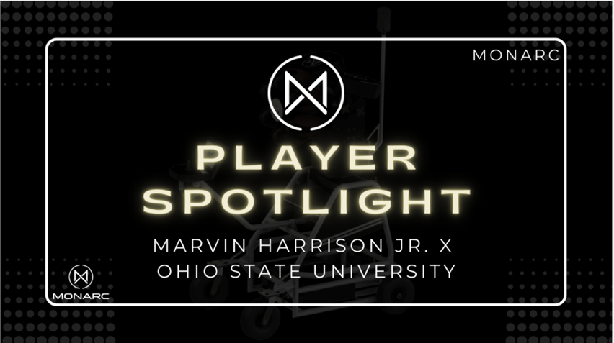

3 Ways The Seeker Perfected Marvin Harrison Jr.’s Gameplay

Marvin Harrison Jr. and Ohio State football see incredible improvement since implementing the Monarc Seeker.

Dallas, TX. [June 12, 2023] Marvin Harrison Jr. joined the Monarc family on March 2, 2023. Since then, Harrison Jr. and the Ohio State Buckeyes have seen impeccable gameplay improvements. Ohio State saw thousands of extra catches per month per athlete after implementing the Seeker. Harrison Jr. chalks up much of his success to the key ways the Seeker’s technology has helped him and his team’s performance. Some of the key ways the Seeker helps a wide receiver like Harrison Jr. are:

1. The hardware and software enable any game-like and human-like plays and interactions.
2. Compensates for the over-training of quarterbacks and under-training of everyone else otherwise known as the rep gap. This gives players like Harrison Jr. unlimited reps practice.
3. Harrison Jr. receives practice of thousands of extra catches he would not have been able to if were not for the Seeker.

The Seeker’s one-of-a-kind technology revolutionizes a player’s experience. “The Seeker was a big part of my success last season, it allows me to put in work on myself, it keeps me on top of my game,” said Marvin Harrison Jr. "Everyone loved it from the jump...I come out here and run around...Usually I get 150-200 plus catches every time I use The Seeker."
Ohio State is one of the 25 college football programs that have seen a massive improvement since implementing the Seeker. Our subscription service includes hardware, software and service on 3–5-year terms. This type of service allows you to rest assured knowing the product is future-proof and will be the only tool in your program that updates regularly. Monarc cannot wait to watch the ensured success of all future college football partners.
________________________
About Monarc
Monarc is a Dallas-based sports robotic company started by Igor Karlicic and Bhargav Maganti. They invented The Seeker which is the world's first robotic AI quarterback, kicker, and punter. The Seeker was developed to satisfy the demand of players seeking high-volume repetitions for independent catching practice, without requiring a team practice environment. The Seeker has attracted investment from NFL players such as Hunter Henry, George Kittle, and Mohamed Sanu. University of Virginia was the first football team to purchase The Seeker. Monarc now has 25 college football clients utilizing The Seeker to improve their training regime and athletic performance.
To learn more about Monarc for your organization and program, fill out our Monarc contact form and we will be in touch shortly.

Blog Post 3 – "Arizona State Announces Partnership with Monarc"

- Summary:
  - Announces partnership between Arizona State University and Monarc on March 27, 2023. Expand on how cutting-edge technology has been a return on investment. Explains that ASU is joining one of 25 major college football teams that use the Seeker.
- Key Quote:
  - "We have recently been in conversations with Monarc on partnering to incorporate their cutting-edge technology to support football player development. A generous gift was secured to do just that. We have seen immediate impact as our football student-athletes have started spring football, and are spending more time with more flexibility than ever before.” -Jean Boyd, Sun Devil Athletics
Deputy AD and Football General Manager

- Header Image:



Arizona State Announces Partnership with Monarc
Arizona State sees an immediate return on investment after investing in the Monarc Seeker.
Dallas, TX. [June 12, 2023] On March 27, 2023, the Arizona State University football program announced its partnership with Monarc and the new edition of a Seeker subscription for its program. The cutting-edge technology came as a generous gift and has already proven a return on investment for the Sun Devils. Key players like Andre Johnson are already loving and utilizing the practice tool, as it offers the chance to practice human and game-like reps with data analysis.

"We have recently been in conversations with Monarc on partnering to incorporate their cutting-edge technology to support football player development. A generous gift was secured to do just that,” said Sun Devil Athletics Deputy AD and Football General Manager, Jean Boyd. “We have seen immediate impact as our football student-athletes have started spring football and are spending more time with more flexibility than ever before, working on their craft with the help of the Monarc robotic quarterback.”
ASU is joining one of 25 major college football leagues that use the Seeker. The subscription includes hardware, software and update services – ensuring the tool is always up to date. Monarc values its partnerships and considers the approval from athletic department heads like Boyd important to its operations. Monarc hopes ASU can experience some of the same ROI and success as other schools – such as how WVU went from last in conference to 2nd best after Seeker usage.
________________________
About Monarc
Monarc is a Dallas-based sports robotic company started by Igor Karlicic and Bhargav Maganti. They invented The Seeker which is the world's first robotic AI quarterback, kicker, and punter. The Seeker was developed to satisfy the demand of players seeking high-volume repetitions for independent catching practice, without requiring a team practice environment. The Seeker has attracted investment from NFL players such as Hunter Henry, George Kittle, and Mohamed Sanu. University of Virginia was the first football team to purchase The Seeker. Monarc now has 25 college football clients utilizing The Seeker to improve their training regime and athletic performance.
To learn more about Monarc for your organization and program, fill out our Monarc contact form and we will be in touch shortly.

Blog Post Template

TITLE (≤ 12 words)

Subtitle (A one sentence summary of the blog)

City, ST. [Month Day, Year] - Introductory paragraph that includes the most relevant and pertinent information of the blog. Uses 3rd person "Monarc" when stating and summarizing what the news, story or opinion being shared is. E.g.: “Monarc is excited to announce its newest partnership with Arizona State University. ASU will join one of the 25 incredible Monarc college teams who use The Seeker to perfect practicing techniques and better their programs.”

The second paragraph includes quotes from both the Monarc team and partners to embellish the blog. Can include quotes from: college administrators, athletic directors, coaches and team players. Each quote used should solidify the significance of the given blog.

The third paragraph addresses the next steps or what's next given the information in the blog. If the post is about a partnership, you could have this paragraph highlight how Monarc is looking to expand its college team clientele. Could also hyperlink to a different blog with a similar topic. In total, the blog should be between 200-400 words.

____________________

About Monarc
Reuse the same background paragraph in every post to let the audience know a brief overview of the company.

To learn more about Monarc for your organization and program, fill out our Monarc contact form (←always add hyperlink) and we will be in touch shortly.
# 2. Social Posts

Below are 18 social posts that are for the social platforms of LinkedIn and Twitter. Each post has a LinkedIn and Twitter caption copy on the subsequent page. The imagery, design elements, and caption copy were made with the intent of targeting the administrative audience with consideration of the demographic’s age, interests and professional role. The EdCal provided on our asset tracker outlines a 7-week timeline for posting these posts – utilizing Wednesdays-Fridays as they are the more optimal days for reaching LinkedIn and Twitter audiences.

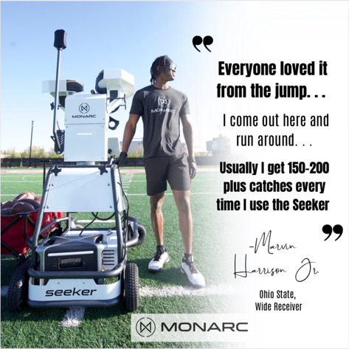 | 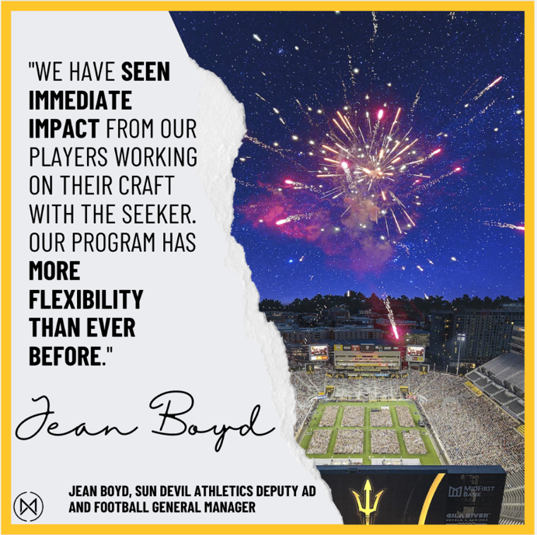
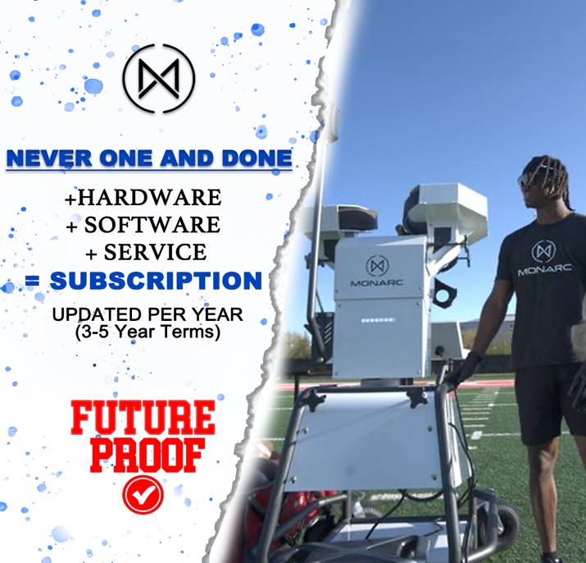 | 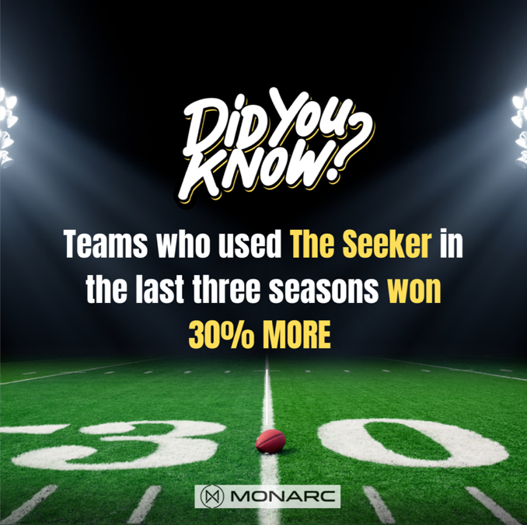
Captions

- LinkedIn: Are you looking for the best college football training tools to improve your program? Ohio State certainty was. Our partnership with the Buckeyes and star player Marvin Harrison Jr. has turned out to be a perfect match. Ohio State was able to make thousands of extra catches per month per athlete after implementing the Seeker. We share all our excitement and insights about how Harrison Jr. Seeker use has perfected his gameplay and changed the OSU program forever in our newest blog 👉 (link) #collegefootball #MarvinHarrisonJr #SuperMarv #ai #technology #robot #blog
Twitter: 3 Ways This Practice Tool Perfected Marvin Harrison Jr.’s Gameplay
(link) This just in: We know the #1 tool Marvin Harrison Jr. and the Ohio State Buckeyes use to perfect gameplay… because we made it! Ohio State was able to make thousands of extra catches per month per athlete after implementing the Seeker. Learn more in our newest blog. #collegefootball #MarvinHarrisonJr #SuperMarv #ai #technology #robot #blog

- LinkedIn: Did you know our newest partner saw an immediate return on
investment after using The Seeker? That's right, Sun Devil Athletics Deputy AD and Football General Manager, Jean Boyd, described it as "seeing an immediate impact as our football student-athletes have started spring football and are spending more time with more flexibility than ever before, working on their craft with the help of the Monarc robotic quarterback." Learn more about how The Seeker has already changed how the Sun Devil's training for the better in our newest blog 👉 (link) #collegefootball #football #ROI #ai #technology #robot #blog
Twitter: Arizona State Announces Partnership with Monarc (link) We are so excited to announce our newest partnerships with the incredible ASU Sun Devils! Read more about the return on investment ASU has already seen from incorporating The Seeker in our newest blog. #blog #ai #collegefootball #partnership #robot

- LinkedIn: Looking for a way to invest in a long-term product with the long-term worry? You are never one and done with a Seeker subscription. Monarc's uses a subscription service that gives teams peace of mind before knowing their product consistently updates – something you cannot say about all other practicing materials or program tools. The Seeker operates on a hardware, software and service program that keeps tool up-to-date. To learn more about the subscription, contact us here 👉 (link)#ROI #subscription #sportstechnology #college football
Twitter: You are never one and done with a Seeker subscription. Monarc's uses a subscription service that gives teams peace of mind before knowing their product consistently updates – something you cannot say about all other practicing materials or program tools. We guarantee that each year your program uses the Seeker, the more it'll become your favorite subscription yet. #ROI #subscription #sportstechnology #college football

- LinkedIn: Are you looking for a potential ROI in every purchase you make for your college football team? We know the worry. If you partner with us, you can be rest assured knowing teams who use the Seeker win 30% more than before implementation. As Clemson’s Wide Receiver Noble Johnson said, “If you don’t got a Monarc I don’t know what you’re doing! This is the reason why you’re not winning the national championship.” Read more about The Seeker here! 👉 (link)#ai #collegefootball #robot #collegefootballtech #collegefootballadministrators
Twitter: In the past three seasons, we have seen our partners win 30% more. A s Clemson’s Wide Receiver Noble Johnson said, “If you don’t got a Monarc I don’t know what you’re doing! This is the reason why you’re not winning the national championship.” We are actively seeking new partners who want to improve their college football programs in ways they never imagined. Read more about The Seeker here!: (link)#ai #collegefootball #robot #collegefootballtech
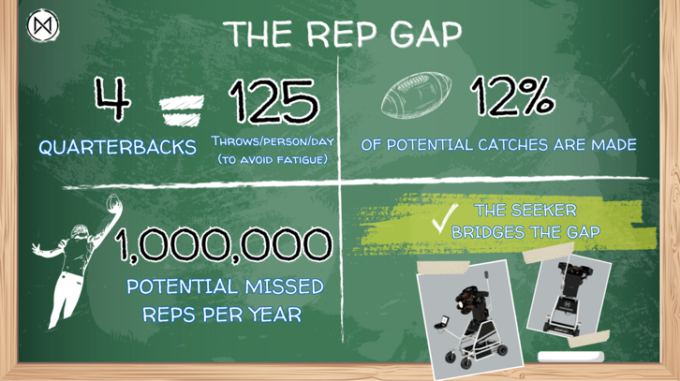 | 
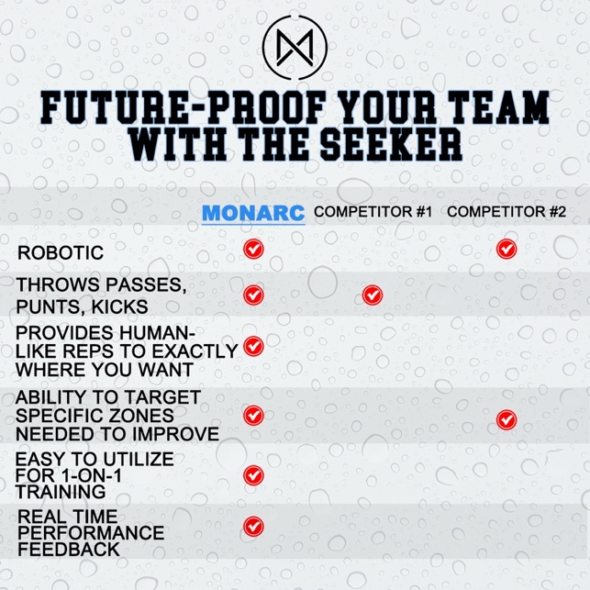 | 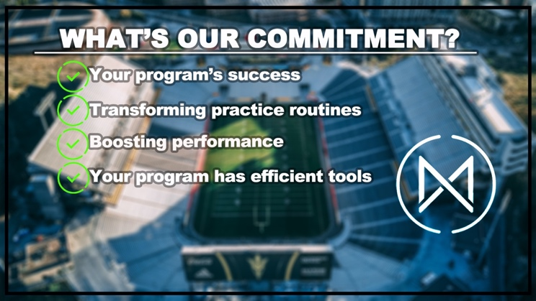

Captions

- LinkedIn: The "rep gap" is the gap that occurs when team practice only 12% of potential plays and miss nearly 1M game-like practices. The Seeker was made with the intention of combatting the rep gap from quarterbacks. The Seeker is an automatic machine that can mimic human-like reps and actively close the gap. Monarc’s The Seeker has the power to help bridge the gap ans secure your team's success. Want to learn more about your team can use our exclusive technology to begin closing the gap? Click here to get started! 👉 (link)#ai #collegefootball #robot #collegefootballtech #collegefootball administrators #repgap
Twitter: Monarc’s Seeker has the power to help bridge the gap of 1 million missed reps per year! Want to learn more about your team can use our exclusive technology to begin closing the gap? Click here to get started!: (link)#ai #collegefootball #robot #collegefootballtech #repgap

- LinkedIn: Want to be the #1 in the nation? The University of Kansas did, which is why they come to us looking to use our innovative technology to improve their team, resulting in them becoming in 2022 the #1 in the nation for the fewest dropped footballs in 2022! Implementing the seeker has helped improve in specific categories which well-round an overall program. Click here to get your team started today! 👉 (link)#ai #collegefootball #robot #collegefootballtech #innovation #footballtechnology
Twitter: Want to be the #1 in the nation? The University of Kansas did, which is why they come to us looking to use our innovative technology to improve their team, resulting in them becoming in 2022 the #1 in the nation for the fewest dropped footballs in 2022! Click here to have your team start today! (link) #ai #collegefootball #robot #collegefootballtech #innovation #footballtechnology

- LinkedIn: We get it. The desire to your future-proof your team can be challenging with so many products on the market. At Monarc, we offer one-of-a-kind features in our Seeker product that makes this hassle easier. We can assure you that an investment with Monarc is the best way to future-proof your college football program. #ai #collegefootball #robot #collegefootballtech #innovation #footballtechnology #futureproof
Twitter: Unlike our competitors, we offer the Seeker mimics human-like reps, 1-on-1 training, and real time feedback. Our innovative technology can't be beat. If you are looking for the best product on the market, we got you covered. Future-proof your program with us – Monarc. #ai #collegefootball #robot #collegefootballtech #innovation #footballtechnology #futureproof

- LinkedIn: Monarc is committed to ensuring The Seeker successfully helps transform your program’s practices by boosting overall performance. To learn more about us and how The Seeker will improve your program 👉 (link)#ai #collegefootball #roboticquarterback #collegefootballtech #footballperformance
Twitter: Monarc is committed to ensuring The Seeker successfully helps transform your program’s practices by boosting overall performance. To learn more about us and how The Seeker will improve your program here!: (link) #ai #collegefootball #roboticquarterback #collegefootballtech #footballperformance

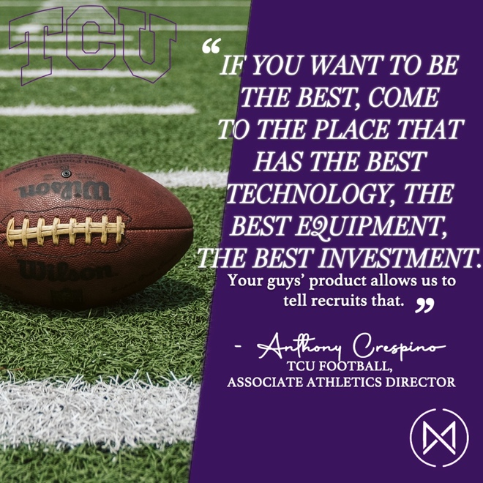 | 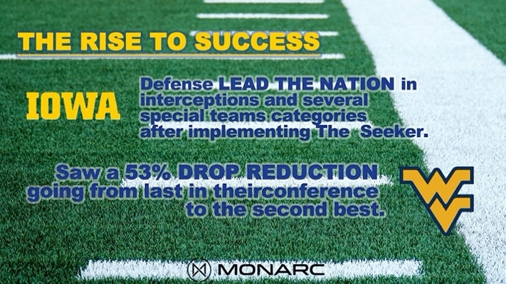
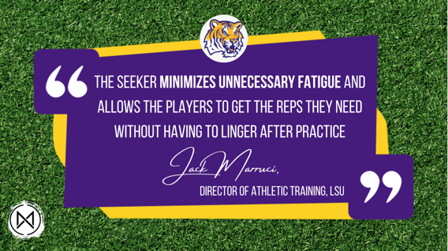 | 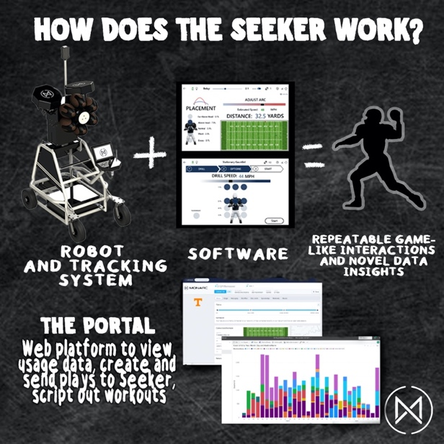
Captions

- LinkedIn: Is your football program investing in the best? How about the future? The future of technology and Monarc has exactly what you need for the value of your investment. Setting your program apart from what other programs have may be difficult but having the next best thing will draw your recruits in. Learn more about how programs are taking their program to the next level and the importance of your investment 👉 (link) #collegefootball #returnoninvestment #robot #technology
Twitter: Is your football program investing in the best? How about the future? The future of technology and Monarc has exactly what you need for the value of your investment. Setting your program apart from what other programs have may be difficult but having the next best thing will draw your recruits in. Learn more about how programs are taking their program to the next level and the importance of your investment 👉 (link) #collegefootball #returnoninvestment #robot #technology

- LinkedIn: College teams have won categories they never knew were possible before the Seeker. The University of Iowa 2021 defense lead the nation in interceptions and several other special teams categories after implementing our AI technology – The Seeker. Additionally, West Virginia saw a 53% drop rate reduction. Are you ready for your team to be next? Click here to learn about how you can secure The Seeker for your team today! 👉 (link) #ai #collegefootball #roboticquarterback #collegefootballtech
Twitter: College teams have won categories they never knew were possible before the Seeker. The University of Iowa 2021 defense lead the nation in interceptions and several other special teams categories after implementing our AI technology – The Seeker. Additionally, West Virginia saw a 53% drop rate reduction. Are you ready for your team to be next? Click here to learn about how you can secure The Seeker for your team today! 👉 (link) #ai #collegefootball #roboticquarterback #collegefootballtech

- LinkedIn: The Seeker' ability to o fulfill the 1 million potentially missed reps per year means that your program will see success and you will see a ROI. "The Seeker minimizes unnecessary fatigue and allows the players to get they reps they need without having to have them linger after practice. We jumped on board with it." said Jack Marruci, Director of Athletic Training at LSU. Secure the product to secure the best ROI your program has seen to date. Check out The Seeker’s AI technology! 👉 (link) #ai #collegefootball #roboticquarterback #collegefootballtech #collegefootballadmin
Twitter: LSU’s Jack Marruci gave great insight on just how impactful the Seeker is on the rep gap. The Seeker' ability to fulfill the 1 million potentially missed reps per year means that your program will see success – and you will see a ROI. #ai #collegefootball #roboticquarterback #collegefootballtech #collegefootballadmin

- LinkedIn: How does The Seeker work? Our robot and tracking system works in conjunction with our innovative AI software to create repeatable game-like interactions and novel data insights! You will then have access to your portals where you can view usage data, create and send plays to The Seeker for practice, and script out your player’s workouts. Interested in purchasing your own? Click here today! 👉 (link)#ai #collegefootball #roboticquarterback #collegefootballtech #collegefootballadmin
Twitter: Want to have the best training tools on the market? Our robot and tracking system works in conjunction with our innovative AI software to create repeatable game-like interactions and novel data insights! You will then have access to your portals where you can view usage data, create and send plays to The Seeker for practice, and script out your player’s workouts. Interested in purchasing your own? Click here today!: (link) #ai #collegefootball #roboticquarterback #collegefootballtech #collegefootballadmin
   | 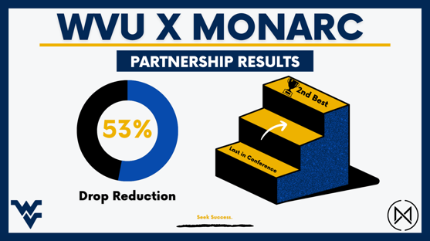  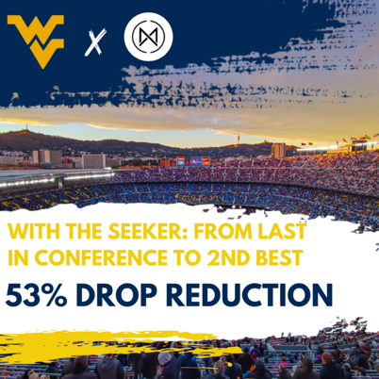
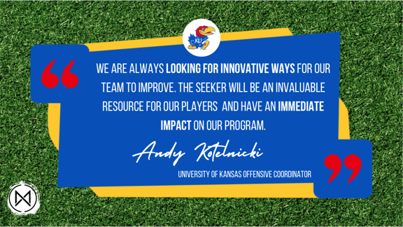 | 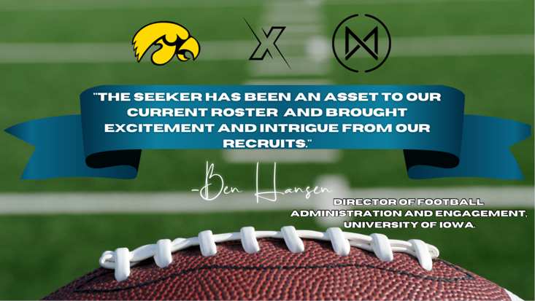

Captions

- LinkedIn: Looking for ways to future-proof your team? Look no further. As the inventors of the world's first robot quarterback, we know all about the rise and importance of AI technology. Choosing to invest in our AI-driven, training platform will help you put your organization on the forefront of the latest training technology. Our proven track record of improving overall team performance will ensure your investment in a future-proof product. The Seeker analyzes data, develops strategies and can mimic human-like reps. Learn more about how you can future-proof your team's success with us in our newest blog 👉 (link)#collegefootball #innovative #ai #technology #robot #blog #futureproof
Twitter: How The Seeker's AI Technology Will Future-Proof Your College Football Program (link)At Monarc, we know there is no better way to leave an impact on a college football program you run other than future-proofing its success. To join us in leaving programs stronger and better prepared for the future of football training practices, check out our newest blog. #collegefootball #innovative #ai #technology #robot #blog #futureproof #legacy

- LinkedIn: Unleashing the potential of AI technology in football! The Seeker’s game-changing technology turned the tables for WVU, propelling them from last in their conference to a remarkable 2nd place with an astonishing 53% drop reduction. Witness the future of sports innovation and team up with Monarc. 👉 (link)#CollegeFootball #AI #Technology #Football #ai #quarterback #tech
Twitter: Witness this incredible transformation! Thanks to The Seeker, WVU went from last in their conference to becoming the 2nd best team with a staggering 53% drop reduction. Experience the power of AI revolutionizing football here! (link) #transformation #AI #collegefootball #technology #roboticquarterback

- LinkedIn: AI is positioned to be the biggest disrupter in sports. The seeker helps you harness this new technology to win more. Andy Kotelnicki, the University of Kansas offensive coordinator, shared just how impactful the innovation has been on his program in Kansas. We are thrilled as Kansas' success and look forward to our many future partners who will secure their programs future through the Seeker. Want to learn more? Contact us here (link) #CollegeFootball #Technology #CollegeAthletes #football #ai #innovation
Twitter: Elevate your game with AI! The Seeker is at the forefront of modern tech advancements, perfectly aligned with the transformative power of AI in sports. Harness this cutting-edge technology to propel college athletes to new heights, surpassing limits and redefining success: (link) #collegefootball #technology #collegeathletes #football #ai #innovation

- LinkedIn: The Seeker is one of the savviest options on the market with a modern interface, pulse tracking system, and automatic 6-ball magazine. One admin who saw the savvy choice was Ben Hansen, football engagement administrator at the University of Iowa, who said, "The Seeker has been an asset to our current roster and has brought excitement and intrigue from our recruits." #collegefootball #innovative #ai #technology #robot #futureproof
Twitter: The Seeker is one of the savviest options on the market with a modern interface, pulse tracking system, and automatic 6-ball magazine. The University of Iowa's Ben Hansen shared with us just how exciting the product has been for the Falcons. #collegefootball #innovative #ai #technology #robot #futureproof

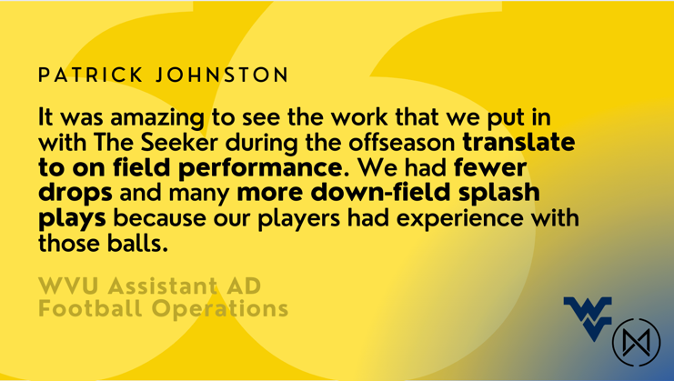 | 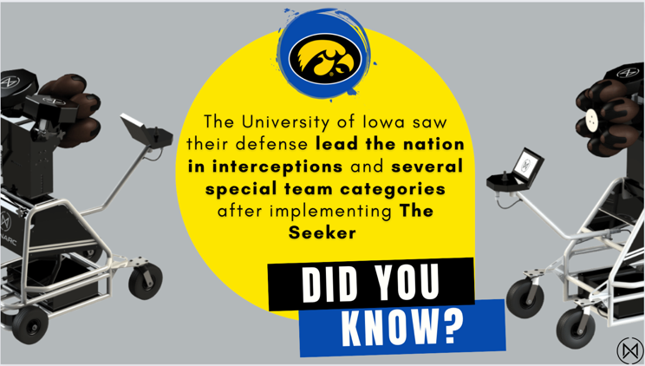

Captions

- LinkedIn: Experience the profound impact of "The Seeker" in revolutionizing on-field excellence! The Seeker's strengthening of team playing results in the conference and special team titles and categories. Testimonial from Patrick Johnson WVU Assistant AD Football Operations – who saw team go from last in conference to 2nd best after Seeker usage – proves just how impactful the Seeker is. Seize the opportunity to unlock your team's full potential and propel them to unparalleled success. 👉 (link) #collegefootball #innovative #ai #technology #robot #futureproof
Twitter: Witness the power of "The Seeker" in transforming on-field performance! Discover how this game-changing technology propelled WVU from last in the conference to 2nd best, with fewer drops and explosive down-field plays! Don't miss out on unlocking your team's potential. Learn more here: (link) #collegefootball #innovative #ai #technology #robot #futureproof

- LinkedIn: Unleash the game-changing power of "The Seeker" in college football! The University of Iowa witnessed a surge in their defense, leading the nation in interceptions and special team categories after implementing this cutting-edge technology. Leave the legacy of implementing The Seeker and set your program apart to unlock its full potential. Join the visionary college football programs and experience the transformation.👉 (link) #collegefootball #innovative #ai #technology #robot #futureproof #legacy
Twitter: Unleash the game-changing power of "The Seeker" in college football! The University of Iowa witnessed a surge in their defense, leading the nation in interceptions and special team categories after implementing this cutting-edge technology. Leave the legacy of implementing The Seeker and set your program apart to unlock its full potential. #collegefootball #innovative #ai #technology #robot #futureproof #legacy

#3. Website

Website and Social Media Posting Engagement Chart

Social Channel | Best Posting Time
Blog Posts | Tuesday afternoon/evening — for social shares. Friday afternoon/evening (and/or typical local paydays) — for affiliate link clicks and purchases. Sunday — for less competition.
LinkedIn Posts | Wednesday from 8–10 AM, Thursday at 9 AM and 1–2 PM, Friday at 9 AM.
Twitter Posts | Tuesdays from 9 AM-2 PM; Wednesdays from 9 AM-1 PM; Thursdays from 9 AM-2 PM; Fridays 9 AM-Noon.

WEBSITE RECOMMENDATIONS
Website Comms. Audit Encompassing SEO Recommendations

Recommendation | Why?
Update website to GA4 | The sooner Monarc makes the switch, the sooner Monarc’s can have a more comprehensive understanding of how future customers, such as college admin, are finding the site, staying on the site, what pages they’re looking at, etc. This will be helping with targeting the audience in the future.
Invest time monthly into SEM Rush to understand SEO Keyword Searches | To first understand what users are searching for when they find the website. Then, as time progresses, Monarc can better understand how keyword searches change, such as with new deals, social media campaigns, blog posts, etc. This will help Monarc better understand what keywords to continue using when posting blogs or other website content to gain the best SEO results
Updating About Us Page | This update would include a new “Monarc’s Pledge” to express how Monarc is committed to team improvement. Administrators care about team betterment and are looking for ROI so adding these goals to their website will be beneficial for reaching this target demographic
Update Navigation Tabs | Administrators need to see a clear and well-organized website when first opening Monarc’s home page. Tabs should include “About Us,” “The Seeker,” “Blog,” “Media,” “Careers,” and “Contact.”

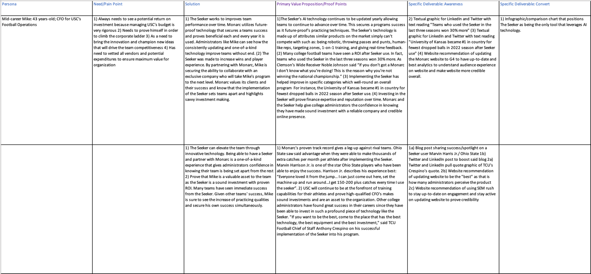
Key Messaging Matrix

Link: https://www.dropbox.com/scl/fi/vl314851yj5vu50kwu7jo/Key-messaging-matrix-Admin-Queens.xlsx?dl=0&rlkey=wyseifmcy2cnon363dn4jboi7

- Resources for optimizing key messages in content posted for the administrative audience

Asset Tracker

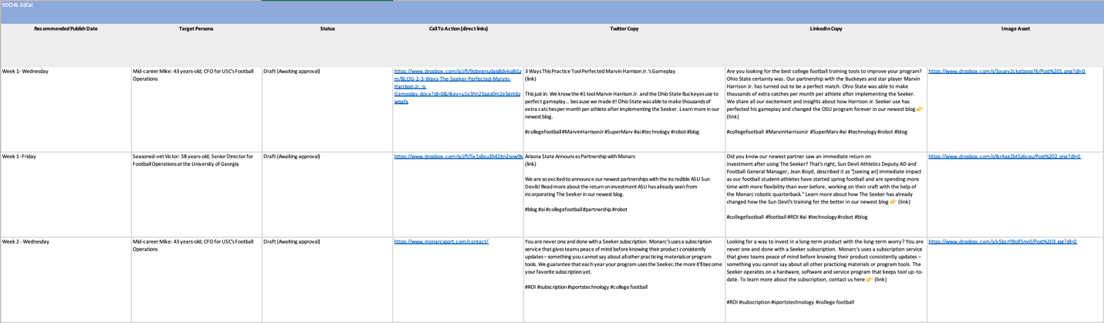

Link: https://www.dropbox.com/scl/fi/mjej9cooqbol9b3zyqslr/Asset-Tracker-Admin-Queens.xlsx?dl=0&rlkey=crocthk858sbx5il57ou63qmj

- Access to all deliverables

Next Steps & Future Recommendations

Next Steps

The first next step for Monarc is to hire a website designer to reconstruct the Monarc website. The budget we have provided accounts for a one-time use of a Fivver-Pro website designer who could help implement the website recommendations we have provided. We then suggest updating the website’s navigational tabs along with the overall website revamp. There should be monthly checks to find any SEO Keyword changes for the website and blogs that are implemented accordingly to optimize website effectiveness. Subscribe to Sem Rush “Guru” to gain key insights on SEO changes and website’s success.

One of the new website tabs will be called “Blog” – where the three blog post deliverables can be posted. These three blog posts should be hyper-boosted via LinkedIn and Twitter, by using the three corresponding social posts provided.

Monarc should follow the 7-week EdCal to post the 18 posts with corresponding captions on LinkedIn and Twitter. The Twitter campaign provided will require subscribing to “Twitter Promote” which is $99/month. The LinkedIn campaign provided will require spending $25/day on boosting posts. Utilize LinkedIn’s “Boost” feature for the LinkedIn campaign. Use the settings of “objective,” “audience,” and “job titles” to hyper-focus the campaign on “college athletic department administrators” “college football administrators,” and or “college football department leads” – for example.

Future Recommendations

For future recommendations, we first ask that Monarc consider continuing to renovate its website to keep the attention of administrators and show that Monarc is a credible and well-established company. Next, consider using social media joint posts in collaboration with players and teams to furthers cross-promotion of social media channels. This will further both Monarc’s social media footprint while also reaching a wider audience.

Regularly implement blog posts through the newly updated website, aiming for 1-2 blog posts a month. Monarc should consider using high-quality cameras or professional photographers for product photography and gathering on-field assets that can be implemented in future blog posts and social media campaigns. We recommend investing in professional photography packages at least once a month which could mean an additional cost of roughly $5,000.

Lastly, we recommend considering hiring a social media/content curator intern for 3 months at roughly $20-25/hour for 40 hours/week, which nets out to an additional estimated total cost of $9-12,000. This intern could create content during said three-month period that could be used throughout the calendar year by Monarc.

Carter (2016), “How Blogging Can Boost Your Customer Engagement and Retention,” https://blog.accessdevelopment.com/how-to-use-your-blog-for-customer-engagement-and-retention
Barmer (2014), “Just how popular is social media among faculty and admin?,” https://www.ecampusnews.com/it-leadership/2014/03/28/just-popular-social-media-higher-ed/
Quinn (2022), “These Delaware startups are using tech and data to elevate college football recruitment,” https://technical.ly/software-development/delaware-startups-college-football-recruitment-hx-innovations-ai-whoo/
Boettger, “An Analysis On College Football Return Of Investment,” https://athleticdirectoru.com/articles/analysis-of-college-football-return-on-investment/
“NCAA Demographics Database,” https://www.ncaa.org/sports/2018/12/13/ncaa-demographics-database.aspx
“Athletic Directors Demographics and Statistics,” https://www.zippia.com/athletic-director-jobs/demographics/
https://www.pewtrusts.org/en/trend/archive/winter-2018/how-generation-x-could-change-the-american-dream
Currier (2018), “How Generation X Could Change the American Dream”, https://khoros.com/resources/social-media-demographics-guide
Thompson (2014), “Which Sports Have the Whitest/Richest/Oldest Fans?,” https://www.theatlantic.com/business/archive/2014/02/which-sports-have-the-whitest-richest-oldest-fans/283626/
Shutterstock, https://www.shutterstock.com/image-photo/portrait-handsome-caucasian-man-formal-suit-2142820441
iStock, https://www.istockphoto.com/photo/be-a-leader-and-a-boss-gm882261976 245533602?phrase=caucasian%20male%20business
WSC Sports: WSC Sports (2023), @wsc_sports, [Instagram Account], https://www.instagram.com/wsc_sports/?hl=en WSC Sports (2023), @wsc_sports, [Instagram Account], https://twitter.com/WSC_Sports?ref_src=twsrc%5Egoogle%7Ctwcamp%5Eserp%7Ctwgr%5Eauthor WSC Sports (2023), @wscsportstechnologies, [LinkedIn Account], https://www.linkedin.com/company/wsc-sports-technologies/ WSC Sports (2023), @wsc-sports, [YouTube Account], https://www.youtube.com/@wsc-sports WSC Sports (2023), @wsc__sports, [TikTok Account], https://www.tiktok.com/@wsc_sports Catapult Sports: Catapult Sports (2023), @catapultsports, [Instagram Account], https://www.instagram.com/catapultsports/?hl=en Catapult Sports (2023), @catapultsports, [Twitter Account], https://twitter.com/catapultsports?ref_src=twsrc%5Egoogle%7Ctwcamp%5Eserp%7Ctwgr%5Eauthor Catapult Sports (2023), @catapultsports, [LinkedIn Account], https://www.linkedin.com/company/catapultsports/ Catapult Sports (2023), @catapultsports, [YouTube Account], https://www.youtube.com/@CatapultSports Catapult Sports (2023), @catapult_one, [TikTok Account], https://www.tiktok.com/@catapult_one Perch Technology: Perch Technology (2023), @perch.fit, [Instagram Account], https://www.instagram.com/perch.fit/ Perch Technology (2023), @perchFit, [Twitter Account], https://twitter.com/perchFit Perch Technology (2023), @perchfitness, [LinkedIn Account], https://www.linkedin.com/company/perchfitness/ Perch Technology (2023), @perchfit, [YouTube Account], https://www.youtube.com/@PerchFit Monarc:
Monarc (2023), @monarcsport, [Instagram Account], https://www.instagram.com/monarcsport/?hl=en
Monarc (2023), @monarcsport, [Twitter Account], https://twitter.com/monarcsport?lang=en
Monarc (2023), @monarcsport, [LinkedIn Account], https://www.linkedin.com/company/monarc-inc/
Monarc (2023), @monarcsport, [YouTube Account], https://www.youtube.com/@monarcsport
Monarc (2023), @monarcsport, [TikTok Account], https://www.tiktok.com/@monarcsport
WSC Sports (2023), website, https://wsc-sports.com/
Catapult Sports (2023), website, https://www.catapultsports.com/
Teamworks Elite (2023), website, https://www.teamworks.com/blog/ohio-state-leans-into-digital-transformation-with-teamworks-elite-partnership
Ads Target, https://adstargets.com/blog/twitter-ads-costs-2022/#:~:text=The%20cost%20of%20promoting%20a,capitalize%20on%20high%2Dperforming%20tweets.
LinkedIn, https://www.linkedin.com/help/lms/answer/a446611/boost-a-post-from-a-linkedin-page?lang=en
SEM Rush, https://www.semrush.com/pricing/
Platt (2023), https://www.top10.com/website-builders/reviews/fiverr
Lochery (2022), When Is The Best Time To Publish A Blog Post? (The Controversial Truth)” https://bloggingwizard.com/best-time-to-publish-a-blog-post/
Santora (2023), “Best Times to Post on LinkedIn to Increase Your Engagement in 2023,” https://influencermarketinghub.com/best-times-to-post-on-linkedin/
Keutelian (2023), “Best times to post on Twitter in 2023,”https://sproutsocial.com/insights/best-times-to-post-on-twitter/

